Experimental Procedure
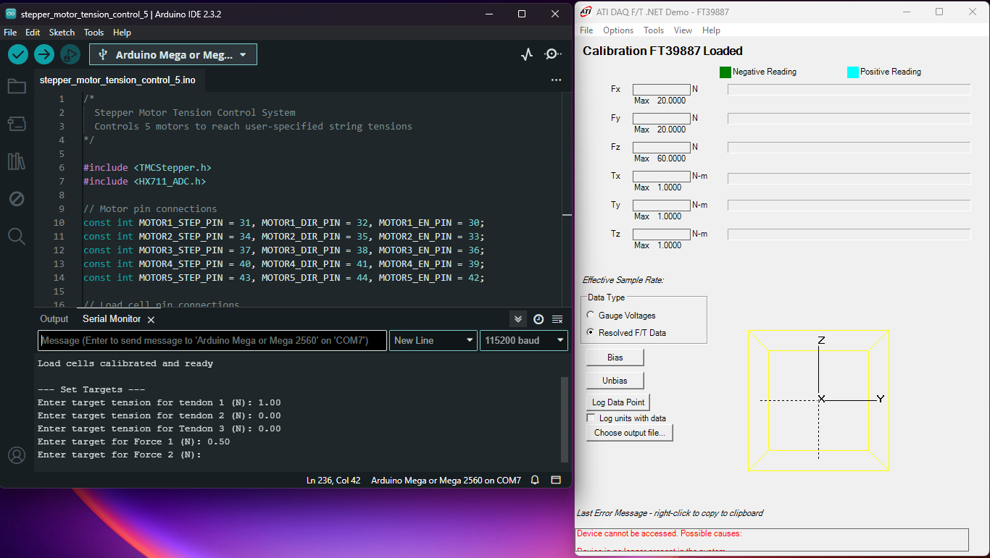
- System Initialization: The ATI force/torque sensor, microcontroller, data logging software, and motor control script were powered on and initialized.
- Configuration: Loading cables were attached to the robot at arc lengths $s_{1}$ and $s_{2}$. The test rig gimbal arms were pre-positioned so that the loading cables create approximate angles $θ_{1}$ and $θ_{2}$. Loading cables were attached to the robot at arc lengths $s_{1}$ and $s_{1}$.
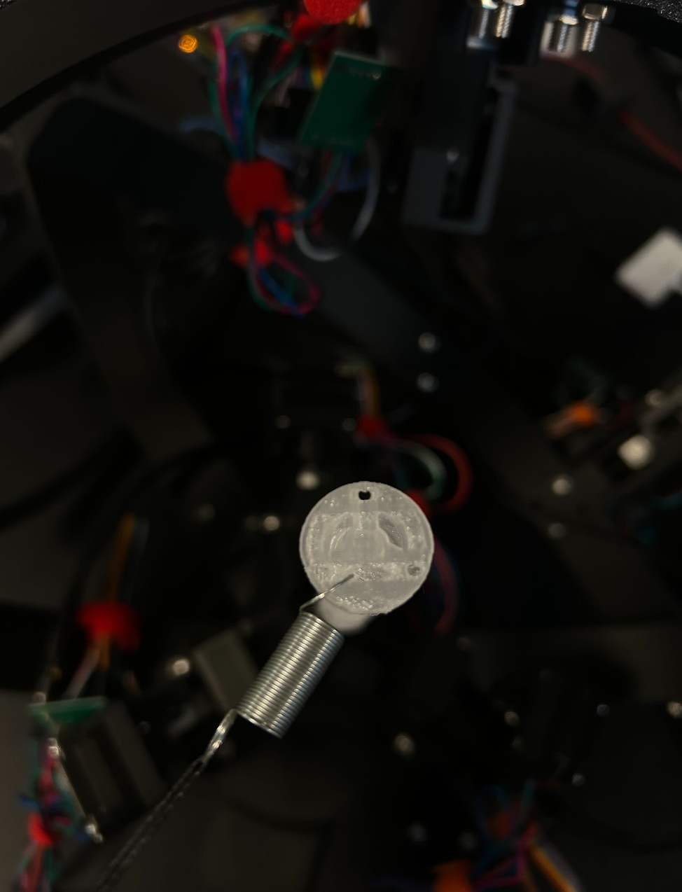
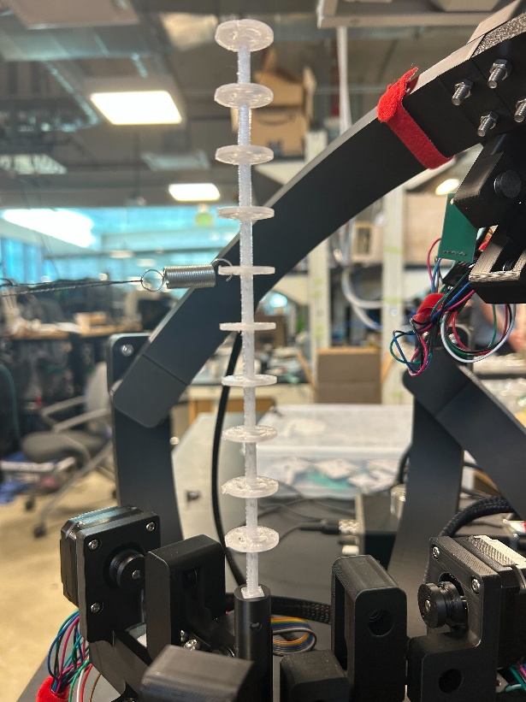
θ
y-axis

s

- Calibration: With all cables slack to prevent residual loading, the ATI sensor was tared to zero.
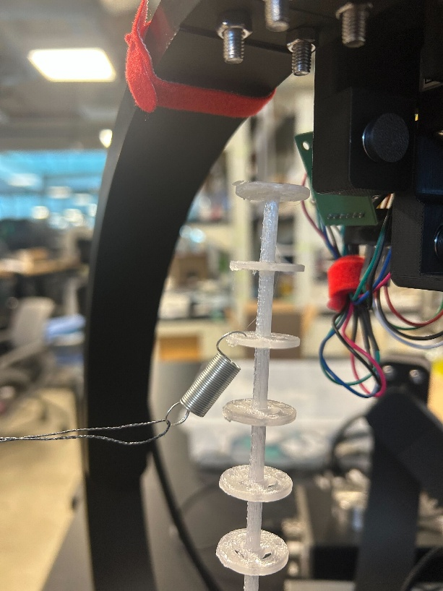
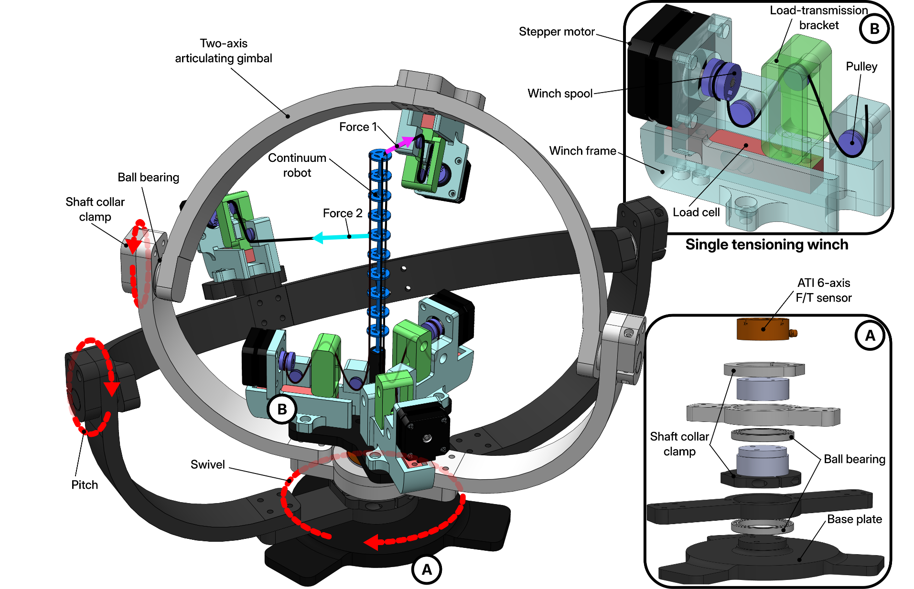

- Actuation: Target tendon tensions $τ_{1}$, $τ_{2}$, $τ_{3}$ and external loads $F_{1}$ and $F_{2}$ were entered in the motor control script, triggering the winches to tension the cables automatically.

- Geometric Alignment: Upon reaching steady-state equilibrium, the gimbal arms were manually adjusted to correct deformation-induced shifts. This ensured the loading cables remained perpendicular to the backbone at their points of contact and aligned with target angles $θ_{1}$ and $θ_{2}$ in the loaded state.
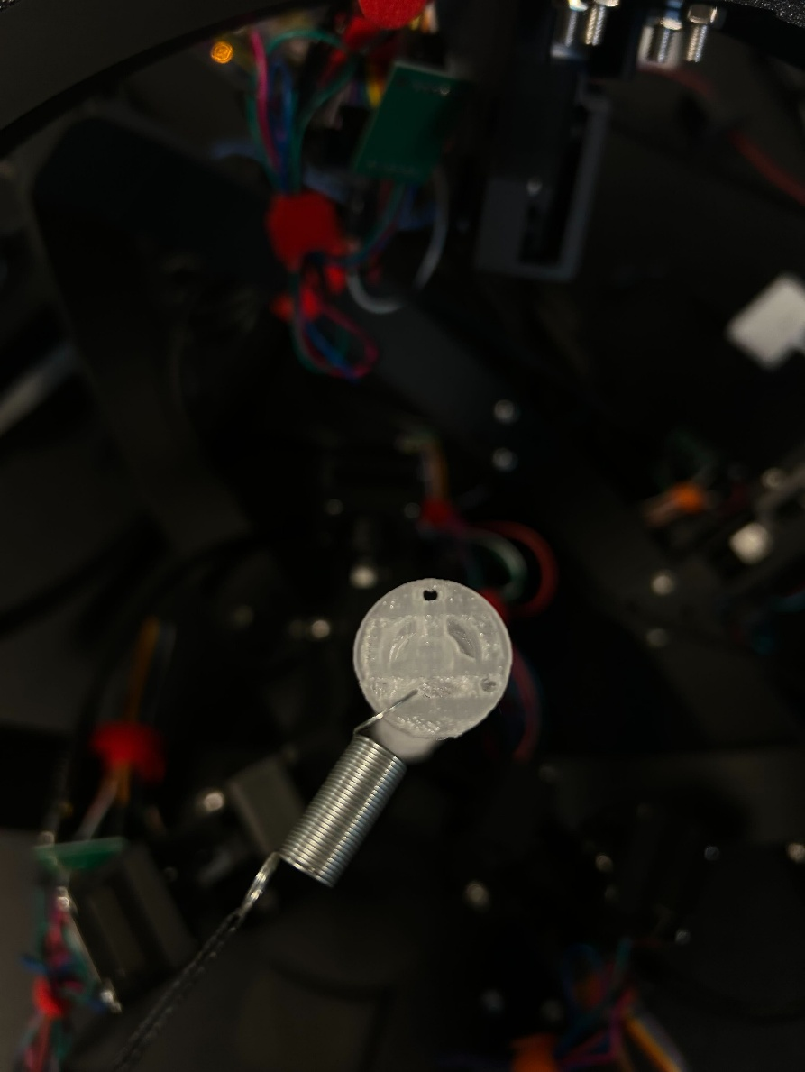
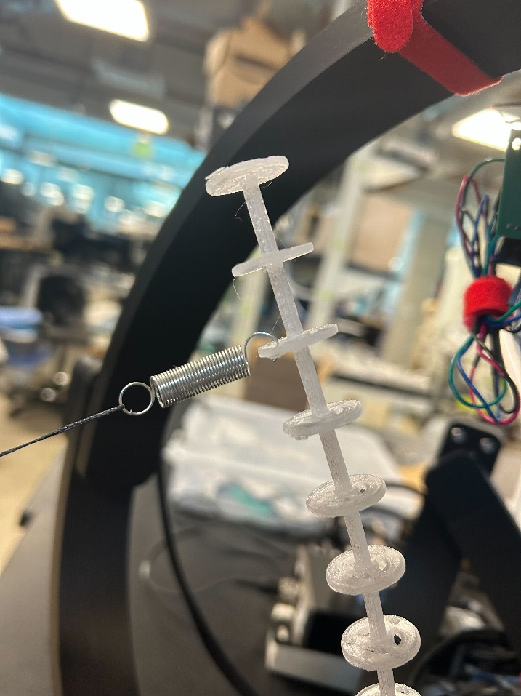
θ
y-axis
90°
- Re-tensioning: To mitigate hysteresis induced by these manual adjustments, the motors were relaxed, and the calibration and actuation steps were repeated.
- Data Acquisition: Once the robot reached steady-state equilibrium and cable alignment was visually confirmed, the proximal wrench was recorded.
- Iteration: This procedure was repeated for all test configurations.

